Color Mixing

<https://github.com/penoel/Color-Mixing>



As you know the mixing of light is additive, so when red, green, and blue light are added they make white. This is the foundation of how tvs and computer monitors work. If you look real close with a magnifying glass at a tv you will see three color bands. It is easier with those bulky old tvs, as they have larger pixels. You even have three types of cones in your eyes to see short, medium, and long wavelengths.

In this project you will build a simple color mixer. This is accomplishes by having voltage dividers connected to red, green, and blue pins of independent RGB leds. The voltage for each is connected in parallel to a central RGB led. Meaning that the voltage on the independent red led is the same as the red pin on the central RGB led. This led will have the addition of each of the independent leds, so you can vary the voltage on any of the independent leds to either add or decrease the amount of a specific color.

The board was designed to in the shape of led facing the same orientation as the leds used, ideally this will aid in the polarity placement of the leds. The leds are common cathode and the cathode pin is marked with a negative sign. The potentiometers were chosen because they have anchor points, so you don’t have to worry about work hardening or sheering as much.

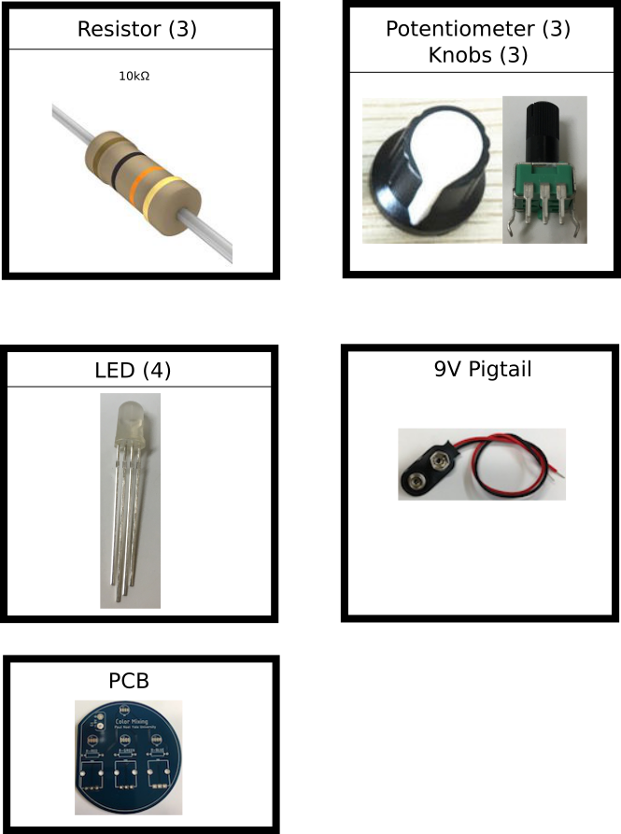

1. Gather all of the components, wet your sponge, and turn your soldering iron on
2. Always start with the smaller tightly pack parts when soldering, for this kit it is the three resistors
3. Bend the legs of the resistors to 90 degrees, then place them in the holes
4. After the legs are in the holes and the resistors are seated bend the legs against the board
5. Solder each leg making sure that the iron touches both the pad and leg
6. Next solder the leds, and the 9V pig tail (be mindful of the polarity)
7. Lastly solder the potentiometers, the board anchors should hold them onto the board, but be sure that they are aligned nicely
8. Place the knobs on the pots, and connect the battery

**Color mixing operation**:

1. Vary the voltage by adjusting the potentiometer
   1. Try to get the led to just barely light up
   2. Now try to light up a second led (observe the mixed led)
   3. Try each combinations and different brightness for each

**Electronic Part Vendors to obtain additional components**:

* Mouser Electronics ([http://www.mouser.com](http://www.mouser.com/))
* Digikey ([http://www.digikey.com](http://www.digikey.com/))
* Newark Electronics (<http://www.newark.com>)
* Sparkfun ([http://www.sparkfun.com](http://www.sparkfun.com/))

Notes

The current limiting resistors are large and can be adjusted for each led. The large value was picked because the cheap potentiometers have a large resistance, this limits the range of the voltage divider (unless both have similar resistances).